Biography: Anntonette (Anny) Dailey

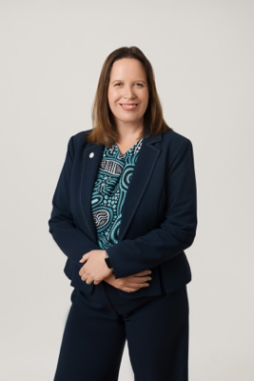

Anntonette Dailey is a fellow and chartered executive engineer bringing more than 20 years senior executive capability, working across the private sector, multiple Government agencies, not for profit and consultancies.

Anny is an expert in Government Relations and technology and has c-suite experience as a CEO and COO.

Anny is currently the chief executive for Aviation/Aerospace Australia. A/AA is an inclusive, purpose-led organisation committed to sustainability of the aviation, aerospace, and space sectors in Australia.

She has a ministerial appointment to the Australian Research Council as part of the Advisory Council. She also has a ministerial appointment to the Defence Council of Victoria where she advises the Victorian Government on strategies to develop and sustain Victoria's defence and space industry capabilities. She is also a Board member for Space Industry Association of Australia.

Anny recently completed a Masters of National Security Policy and is currently completing in a PhD in Political Science and International Relations, focusing on technology in the Pacific.

Proudly, Anny is an Elevate Scholar and a 2025-26 Superstar of STEM.

As a vocal proponent of diversity, Anny has been a natural advocate of supporting all forms of diversity, inclusion and equity. She has and proudly built teams with this as a central value. In 2024, Anntonette was a co-founder and inaugural chair for the Australian Space Diversity Alliance.

She is also the co-author of a 2024 Engineers Australia Policy Paper: Growing and Sustaining Australia’s Space Engineering Capability and Competency, Deputy Chair of the National Committee for Space Engineering and member of Canberra Division Committee.

Anntonette was previous the Executive Director at the Australian Space Agency, having commenced as part of the inaugural leadership team in 2018 with responsibilities similar to a chief operating officer. She has worked extensively across Government and recently at Virgin Australia in executive positions.

As a mother to Skye (9) and Flynn (4), Anny enjoys caravanning, renovating, rugby union, netball and car racing.

